Are ROPS worth what they cost?
A study at UK found medical costs from a severe tractor overturn injury can exceed $140,000!  One third of tractor overturn fatalities and serious injuries result in loss of the family farm.  A ROPS is a one-time cost of less than $1,000.  Protect yourself, your family, and your way of life. See your local equipment dealer. Get a ROPS and seat belt on your tractor and buckle up! | 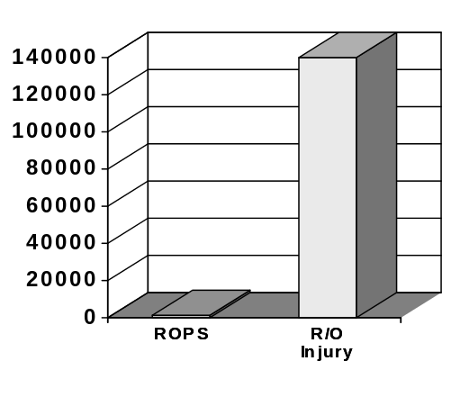  Dollar costs of a ROPS versus an overturn injury
A message from ___________________________________________________________
and the Community Partners for Healthy Farming Project

ROPS and seat belts save lives in more ways than one!
ROPS and seat belts are 98% effective in preventing injury during tractor overturns.  From 1994-99, 76 Kentucky farmers died in tractor overturns.  Another 32 farmers died when they fell or were thrown from a moving tractor.  Altogether, 108 farmers died because they weren’t protected by a ROPS and seat belt.  Your family needs you alive and well. Respect their wishes. Get a ROPS and buckle up! | Kentucky Tractor Deaths 1994-99  Tractor overturns 76  Thrown from tractor, run over 25  Thrown from tractor, not run over 7  Motor vehicle & tractor collisions 2  Total 110  Potential lives saved by ROPS  & seat belts 108  *Two collisions involved large trucks and high speed. ROPS and seat belts would not have prevented these two deaths.
A message from ___________________________________________________________
and the Community Partners for Healthy Farming Project

Kentucky farmers at risk - 1995
In 1995, the Kentucky farm fatality rate was about 3.5 times the national average.  About 60% of all Kentucky farming deaths from all causes are related to tractors.  About 9 out of every 10 tractor-related deaths occur when the tractor overturns or the farmer falls off the tractor. ROPS and seat belts could save nearly all these farmers lives.  If you love your family, respect their wishes for your safety. Get a ROPS and buckle up! | 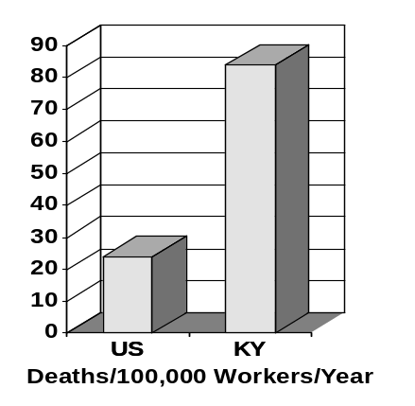
A message from ___________________________________________________________
and the Community Partners for Healthy Farming Project

What happened to these Kentucky farmers?
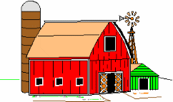  How many farmers are in this picture? | From 1994-99, these 76 farmers died when they overturned tractors without ROPS. Another 32 died when they fell off moving tractors. With a ROPS and a fastened seat belt all 108 could have lived! If your tractors don’t have ROPS and seat belts, you or someone in your family could become another grim statistic.  It’s easy to get a ROPS! They’re available at cost from your local equipment dealer.  Protect your family and yourself. Get a ROPS on your tractor and buckle up!
A message from ___________________________________________________________
and the Community Partners for Healthy Farming Project

What’s a ROPS?
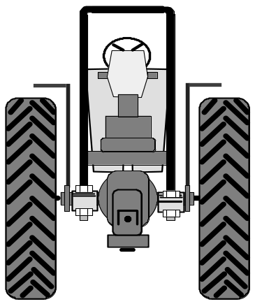 | ROPS - RollOver Protective Structure  During an overturn a ROPS and fastened seat belt hold the operator in a “frame of safety.”  In the past five years, 76 Kentucky farmers died when they overturned tractors without ROPS. Another 32 died when they fell off moving tractors. ROPS and seat belts could have saved all 108 lives.  ROPS are available for most tractors at cost from local equipment dealers usually for less than a $1000 including shipping and installation.  If you don’t have a ROPS on your tractor, you risk being injured or killed if the tractor overturns.
A message from ___________________________________________________________
and the Community Partners for Healthy Farming Project

If this happened to your son...
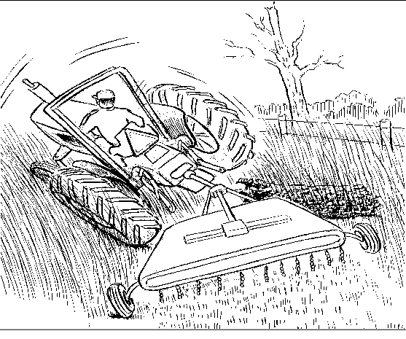 | Wouldn’t you want him on a ROPS-equipped tractor?  Wouldn’t you hope he was wearing the seat belt?  Set a good example! Protect your loved ones and yourself. Get a ROPS and buckle up!  ROPS are available for most tractors at local equipment dealers, usually for less than $1000 including shipping and installation.
A message from ___________________________________________________________
and the Community Partners for Healthy Farming Project

Demonstrating how a ROPS and a seat belt work
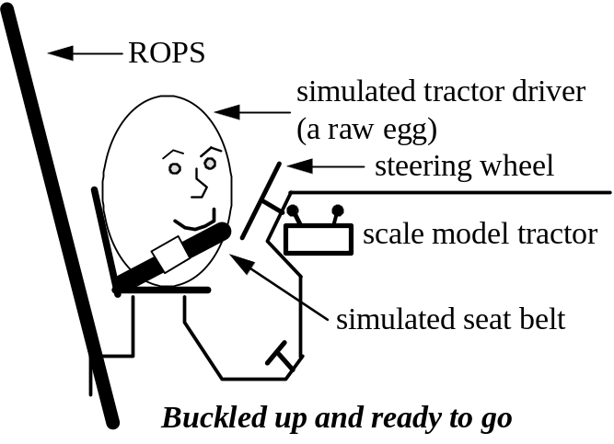 | 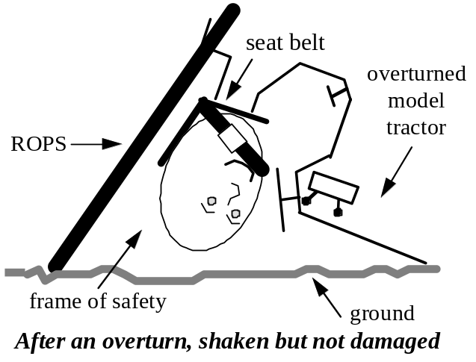
A message from ___________________________________________________________
and the Community Partners for Healthy Farming Project

Effect of overturning a tractor without a ROPS
Living dangerously! (No ROPS, no seat belt.) 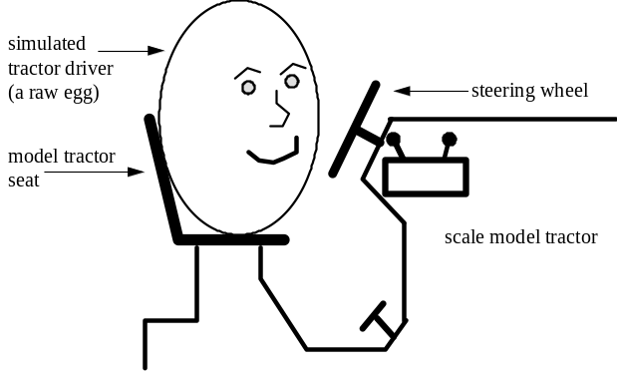  Some folks think a $1000 is too much to spend for a ROPS, so they risk the lives of everyone who drives the tractor. | An overturn without a ROPS!  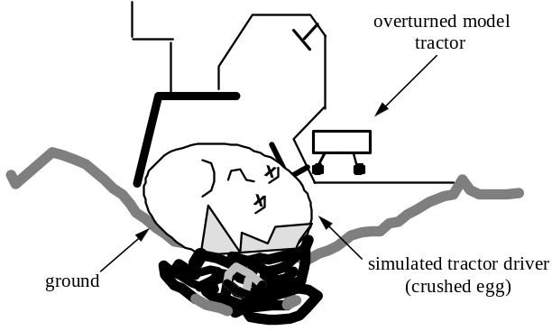  Think of a ROPS as an inexpensive, one-time payment  on a life “assurance” policy for you and your family!
A message from ___________________________________________________________
and the Community Partners for Healthy Farming Project

Age and ROPS status of Kentucky’s farm tractors
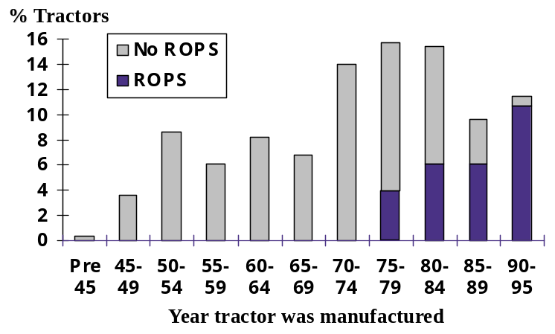 |  | Taken as a whole, the bars represent all of Kentucky’s working farm tractors. Each bar is the percent of tractors manufactured in a given five-year period.  These dark portions of the four bars represent the 29% of tractors that have ROPS. When these tractors overturn, the driver is seldom injured.  The light gray portions of all the bars represent the 71% of tractors without ROPS. When these tractors overturn the driver is often seriously injured or killed. One out of every nine Kentucky farmers overturns a tractor in his or her lifetime.  If your tractor doesn’t have a ROPS you are at risk of a severe injury or death during an overturn.
A message from ___________________________________________________________
and the Community Partners for Healthy Farming Project

Kentucky tractor-related deaths compared to national data
US Average  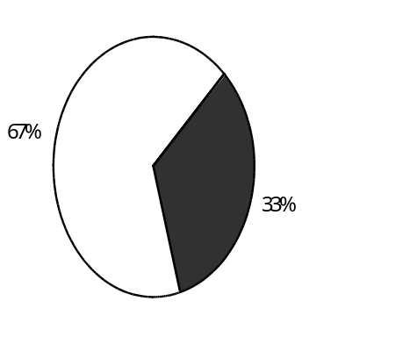  National Safety Council 1998 data | ROPS and seat belts could prevent 90% of Kentucky’s farm tractor-related deaths.  You and your loved ones are at needless risk if you don’t install ROPS and seat belts on your tractor. ROPS for most tractors are available at cost at local farm equipment dealers.  Tractor-related deaths  All other farm deaths |  | Kentucky Average  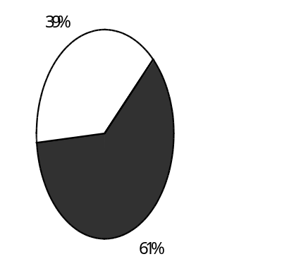  Kentucky Farm Fatality data 1994-98
A message from ___________________________________________________________
and the Community Partners for Healthy Farming Project

Who will fill his shoes?
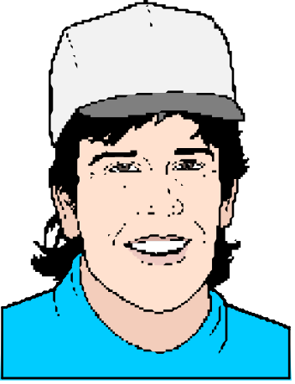 |  | The instant the tractor overturned, their lives changed forever. He was a good husband and father. He loved his wife and kids. They loved him and his way of life as an honest and hardworking farmer. They need him and miss him so much. He won't see his children grow up or enjoy retirement with his wife. Things are hard for his family. It's too late for him and them, but not for you.  Most tractors can be retrofitted with a ROPS and seat belt by your local equipment dealer, usually at a cost of less than $1000 including shipping and installation.  Honor and respect the ones you love. Protect them and yourself by getting a ROPS and seat belt on your tractor.
A message from ___________________________________________________________
and the Community Partners for Healthy Farming Project

Staying on the tractor and in your seat can save your life!
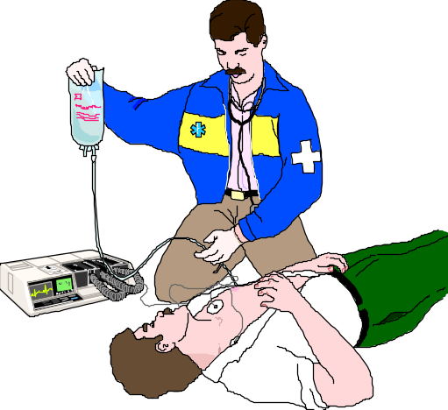 |  | A young farmer was mowing along the side of a road with a bushhog. His tractor had a ROPS but he wasn’t wearing the seat belt. The tractor’s right front wheel hit the edge of a drainage culvert. The farmer was thrown off the tractor and the mower ran over his legs. The tractor remained upright. Two hours later he died on the operating table, leaving a wife and three children who needed and depended upon him.  In a recent six-year period, 32 Kentucky farmers died in similar situations when they fell off moving tractors.  A ROPS provides great protection during an overturn. A fastened seat belt, in combination with a ROPS, keeps you put and out of harm’s way. For the sake of your loved ones, buckle your seat belt when you drive a ROPS-equipped tractor.
A message from ___________________________________________________________
and the Community Partners for Healthy Farming Project

ROPS, seat belts, and the “frame of safety”
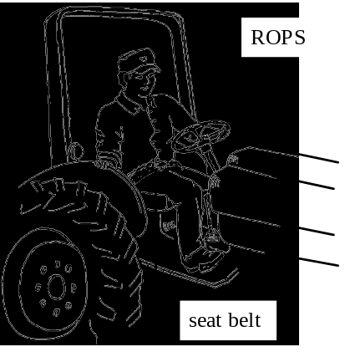  A fastened seat belt holds the driver on the seat ... | 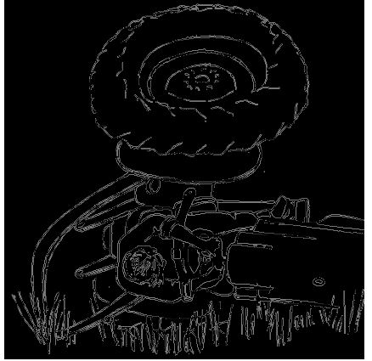  and within the “frame of safety” during an overturn.
A message from ___________________________________________________________
and the Community Partners for Healthy Farming Project

Take the time to buckle up
It only takes a second or two to fasten the seat belt. If you don't do so you can be hurt or killed.  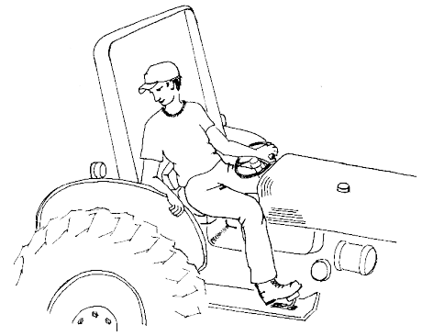 | 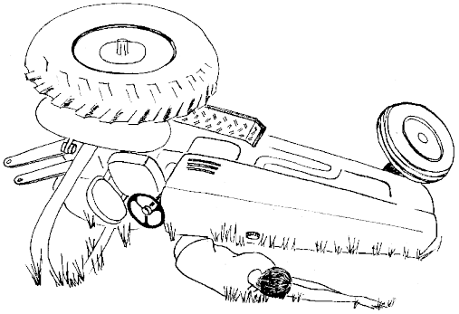  The ROPS saved his life. A fastened seat belt would have saved his legs, huge medical bills, and a permanent disability.
A message from ___________________________________________________________
and the Community Partners for Healthy Farming Project

ROPS can save you and your loved ones
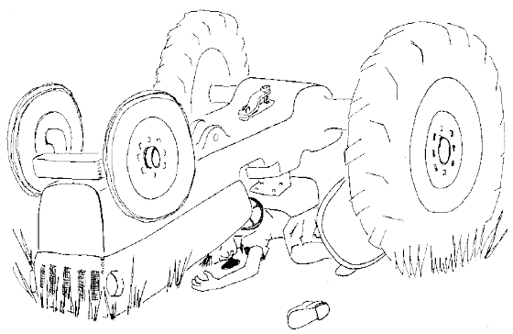  In less than a second the tractor overturned and he was crushed under its weight. In a recent six-year period, 76 Kentucky farmers died in tractor overturns. ROPS and seat belts could have saved all 76 lives. |  | After he died, his wife said, “He knew overturns could be deadly. He believed by being careful he could avoid an overturn. He thought he didn’t need a ROPS on his tractor.” What do you think?  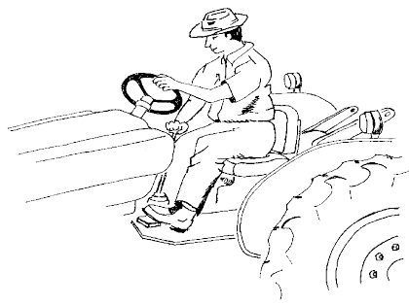
A message from ___________________________________________________________
and the Community Partners for Healthy Farming Project

CONTENTS
Are ROPS worth what they cost?
ROPS and seat belts save lives in more ways than one!
Kentucky farmers at risk - 1995
What happened to these Kentucky farmers?
What’s a ROPS?
If this happened to your son...
Demonstrating how a ROPS and a seat belt work
Effect of overturning a tractor without a ROPS
Age and ROPS status of Kentucky’s farm tractors
Kentucky tractor-related deaths compared to national data
Who will fill his shoes?
Staying on the tractor and in your seat can save your life!
ROPS, seat belts, and the “frame of safety”
Take the time to buckle up
ROPS can save you and your loved ones
Landscaped, three-column listing of equipment dealers -sample 1..….........6
Landscaped, three-column listing of equipment dealers -sample 2..….........7
Mailing, billing, and check stuffer distribution record ……............…........…...…8

